You do not need a professional/installer to pad your facility. Installing wall pads is so easy you can Do It Yourself. Calculating a perfect fit can be tricky but we are here to help. Send us in the dimensions of your room and we will create a custom fit to your room free of charge.

To get started you will need

A friend with a measuring tape
Pencil
Paper
Clipboard

When you walk into your room take a look around and make a note of special objects that you will need to pad and need access to. We have the ability to make customize the size, material, and how to attach the pads.

Doors
Outlets / light switches
Windows
I-beams
Corners
Poles

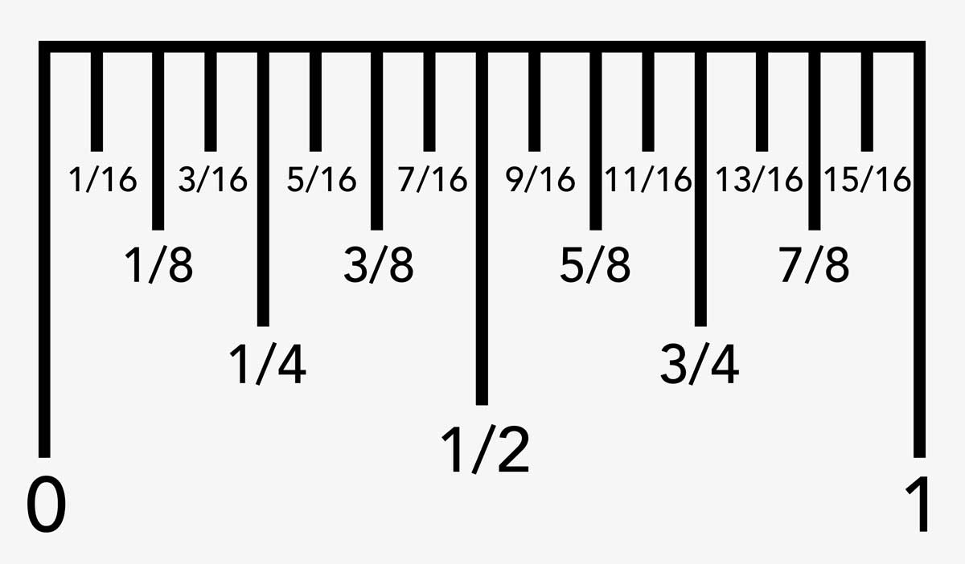

Drawing

Customers find it easiest by starting with a bird’s eye view drawing of the room on paper with a pencil; we do not need anything fancy. Articular blueprints are not good measurements to send, if construction was off by ½ inch, the pads might not fit properly.

Label each wall representing North, South, East, and West. Measure everything precisely. Photos are always encouraged and sometimes required.

Brid’s eye view:

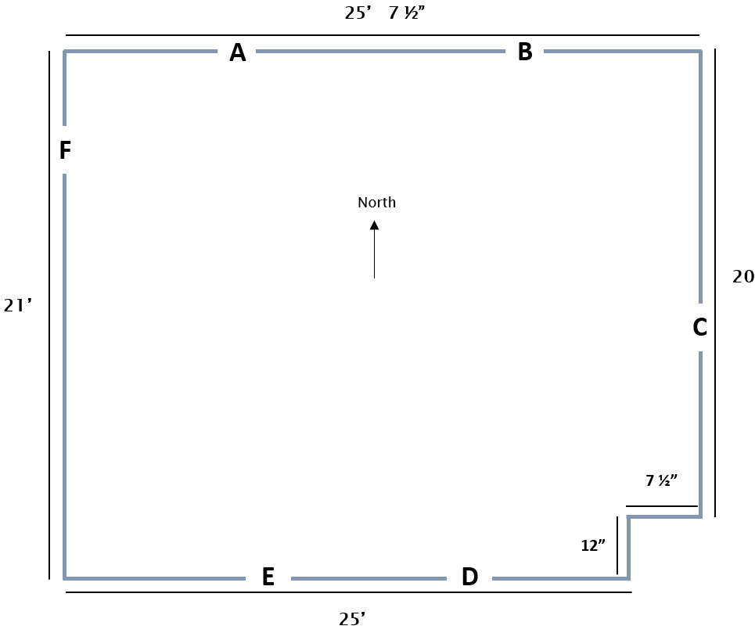

Special obstacles

A: Outlets and light switches
B: Window
C: Column
D: I-Beam
E: Trapper beams
F: Doors

When taking measurements, think about where you are hanging the pad. You may need to install the wall pads above a floor mat or baseboard. To indicate where each obstacle is located at on the wall, always face the wall straight on and start from the left. The bottom of the pad is called the “baseline”, measure from the baseline on up. In the diagrams, the letters represent the measurements needed for cutout.

North Wall: Outlets/light switch and window

If you are wanting to perform outlet and light switch cutouts on site during installation click here to see our 4” x 6” wall pad insert.

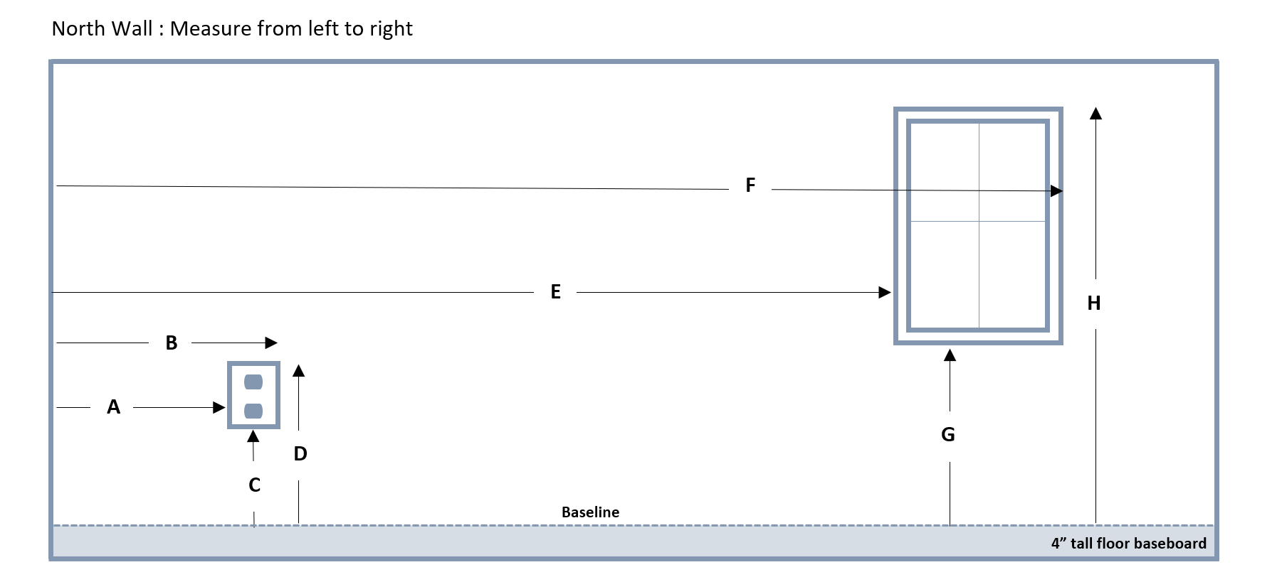

East Wall: Column

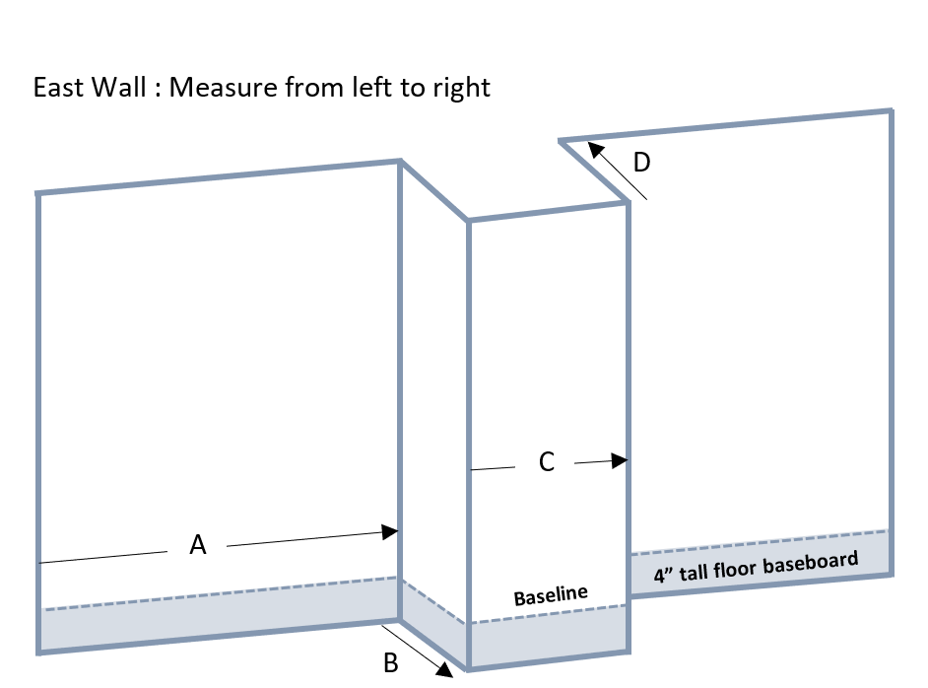

South Wall: I-beam and tapered i-beam

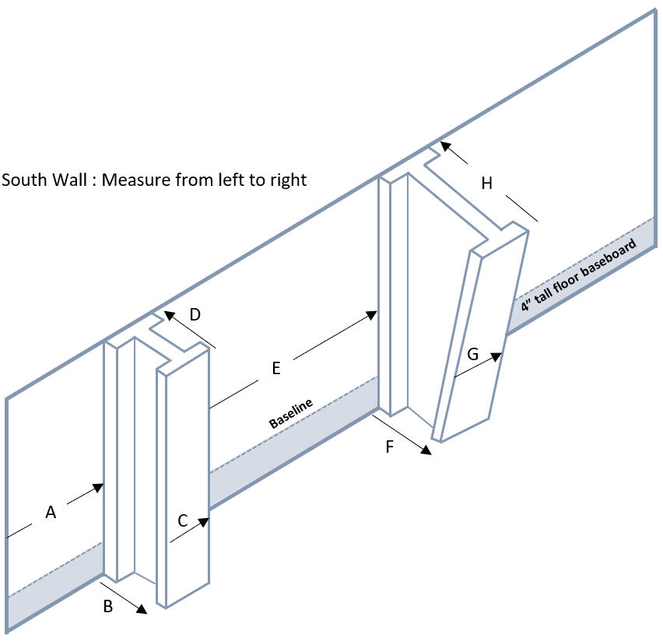

West Wall: Doors

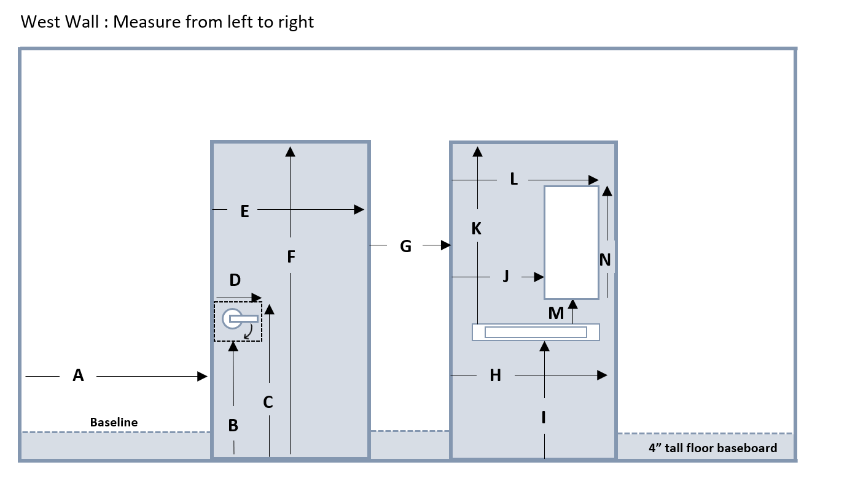
Replacing Existing Wall Pads

If your gym is ready for an update, it is crucial to give the wall measurements and not the existing pad measurements. The outside of the pad is larger than the wall due to the thickness of the foam. Here is an example of an i-beam. The beam is 8 inches wide and the pad is 2” thick. The outside measurements of the pad is 12 inches because you add an additional 4 inches (2 inches for the left side and 2” inches for the right side.)
